DOCKER COMPOSE

* **It is used to build, run and ship the multiple containers for application. It is used to create multiple containers in a single host.**
* **It used YAML file to manage multi containers as a single service.**
* **The Compose file provides a way to document and configure all of the application’s service dependencies (databases, queues, caches, web service APIs, etc).**

* Sudo su –
* Yum install docker -y
* Systemctl start docker
* **Download the docker compose binary**

1)sudo curl -L "https://github.com/docker/compose/releases/download/$(curl -s https://api.github.com/repos/docker/compose/releases/latest | jq -r .tag_name)/docker-compose-$(uname -s)-$(uname -m)" -o /usr/local/bin/docker-compose

2)sudo chmod +x /usr/local/bin/docker-compose

* Docker-compose –version(Verify installation)
* Vi docker-compose.yml(file)

**Excute the commands in the file like given bellow and save with wq!**

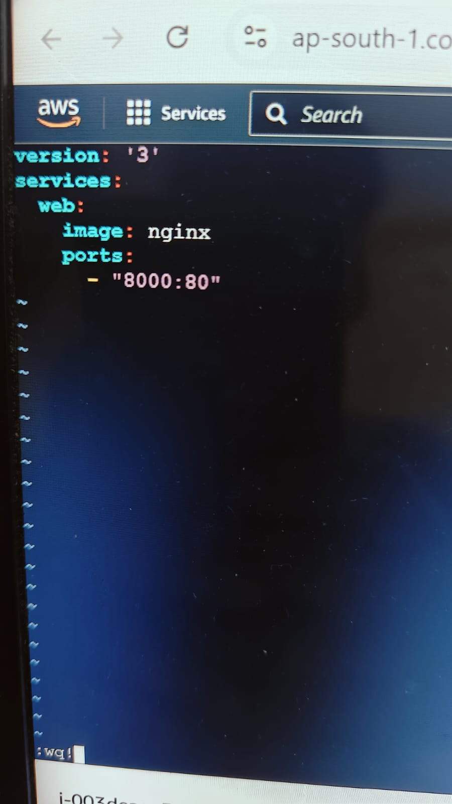

* docker-compose up
* **GO TO SECURITY GROUPADD PORT NUM IN CUSTOMCTP AND PORTRANE 8000**

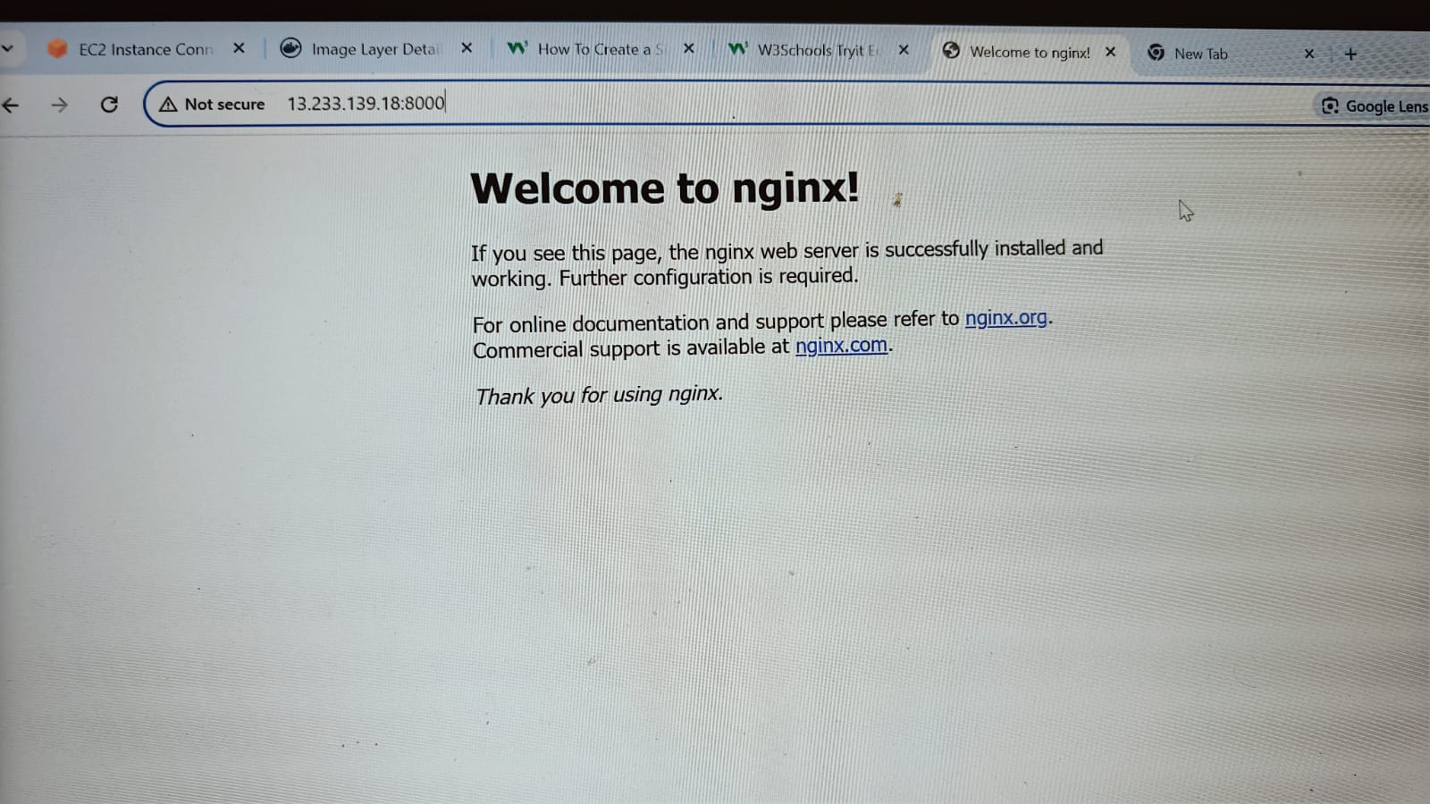

* Run docker compose file
* docker-compose up -d ( its started )
* See the all services
* Docker ps
* See images

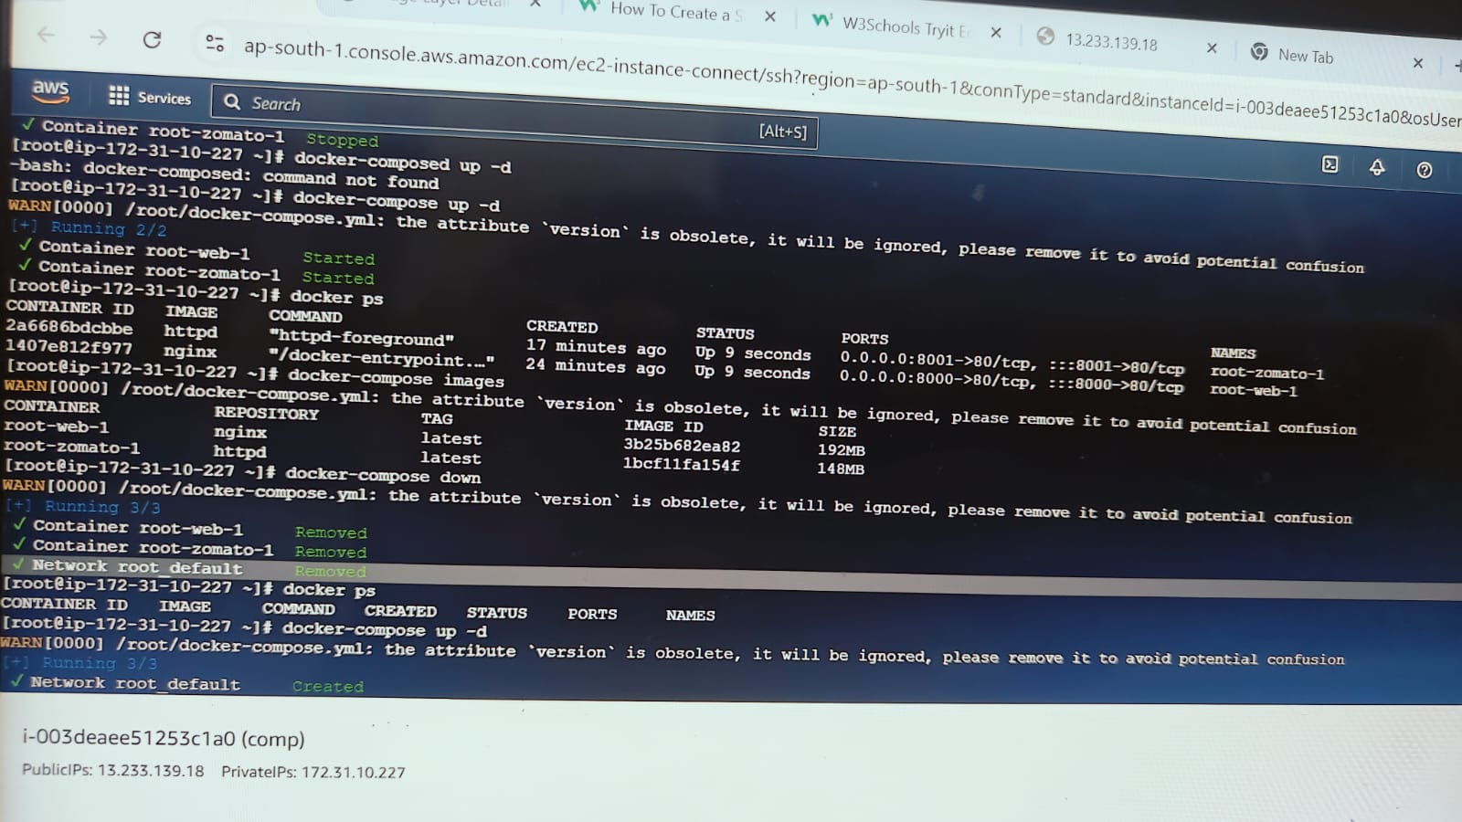

* docker-compose images
* Docker-compose down (to stop the services)
* Docker ps
* docker- compose up -d
* docker ps



* vi docker-compose.yml

**excute the file like given bellow and save with wq!**

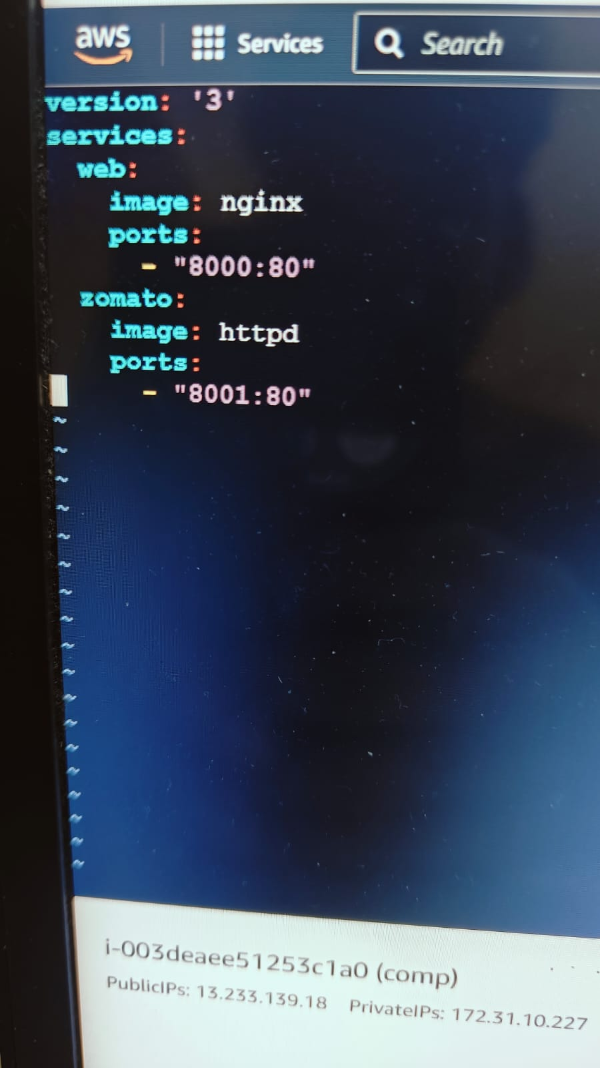

* docker-compose up
* **GO TO SECURITY GROUP ADD ALL TRAFFIC**

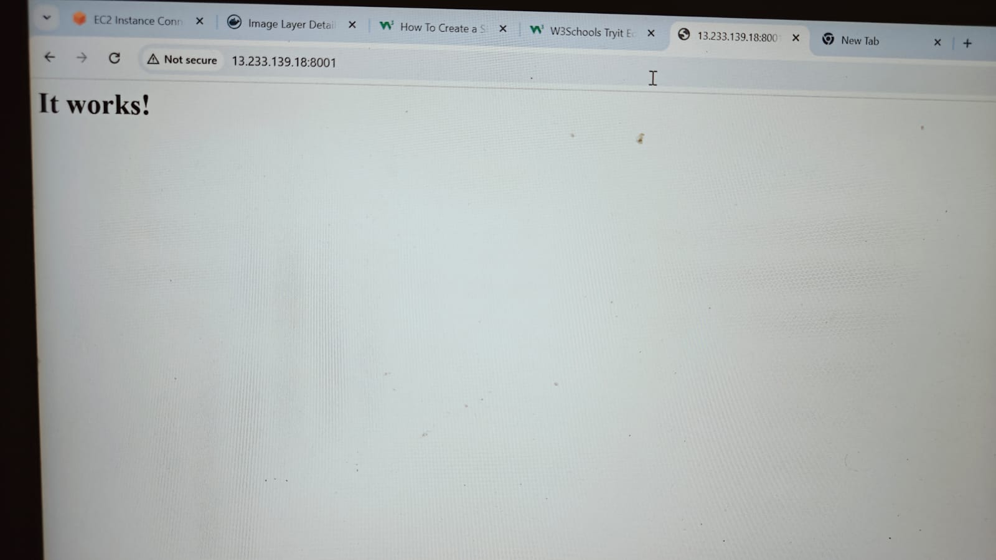

* **GO TO GOOGLE SEARCH dockerhub login**
* docker login
* username :
* password :
* Vi index .html

**Copy matter from html login page and paste and save like given bellow**

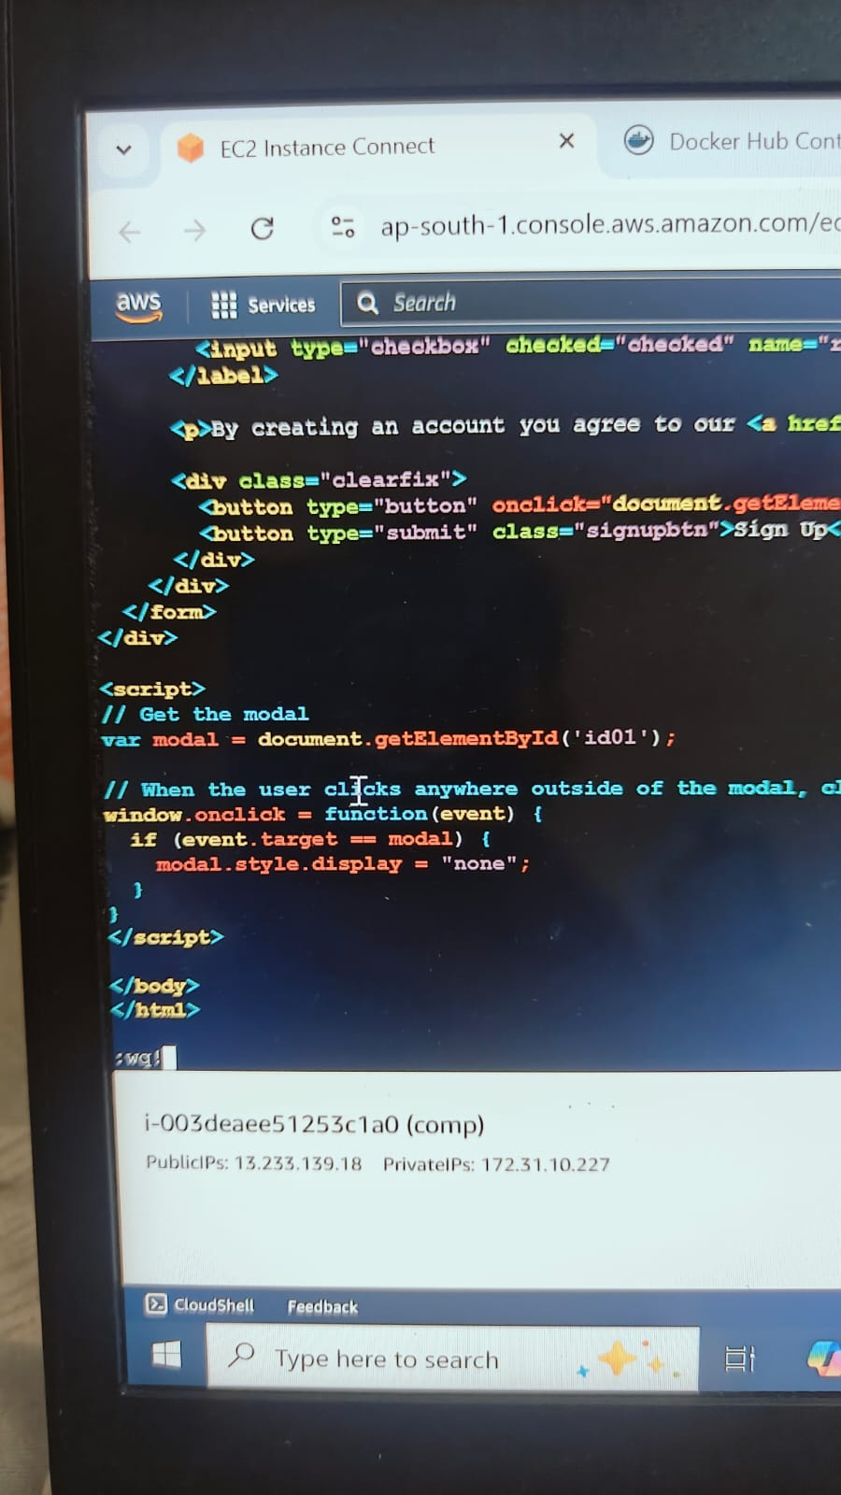

* Ll
* Docker login
* USERNAME
* PASSWORD

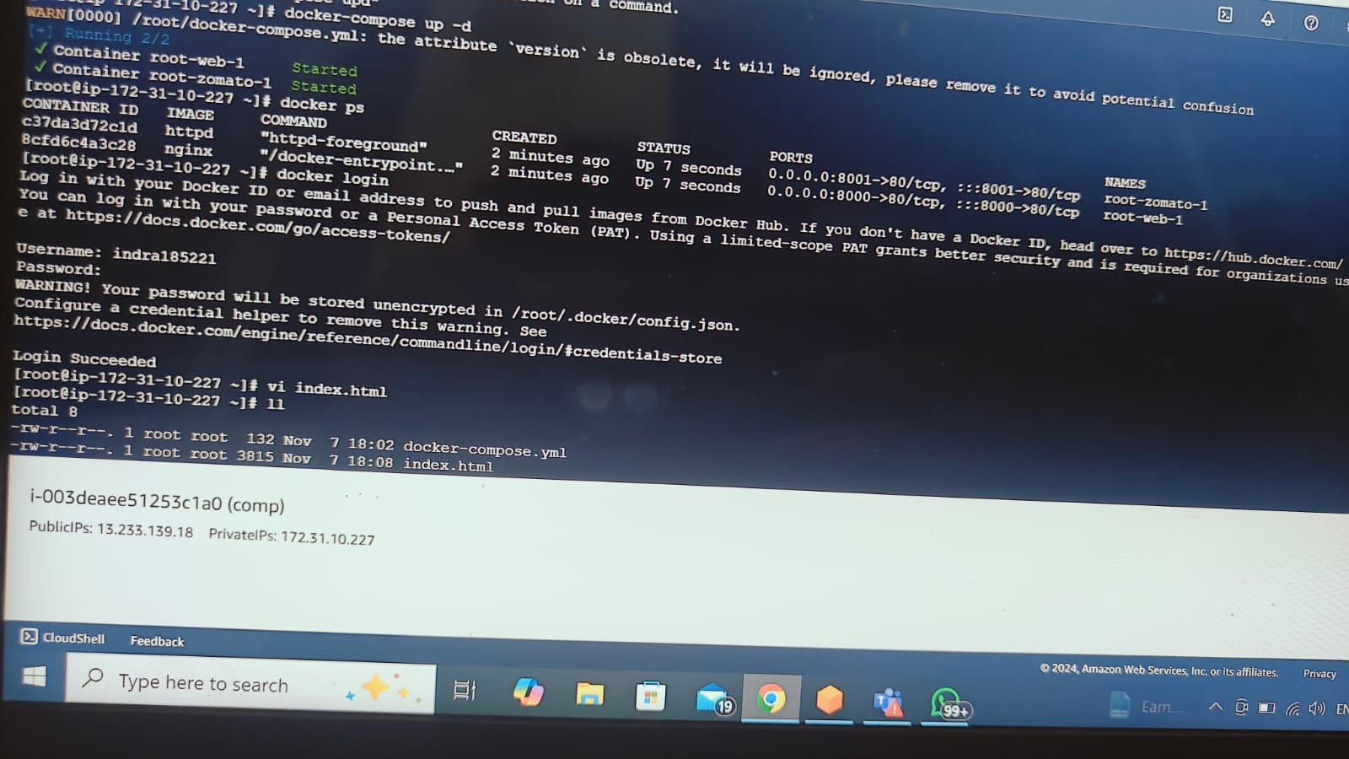

* Vi docker-compose .yml

**EXCUTE MATTER LIKE GIVEN BELLOW**

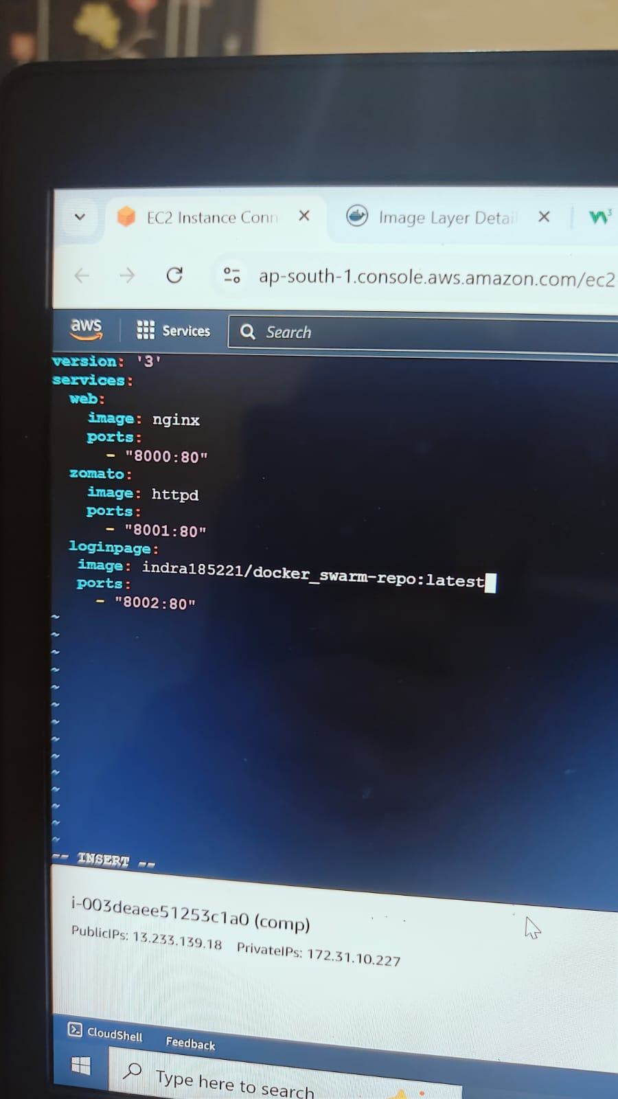

* Docker-compose up -d
* Docker ps

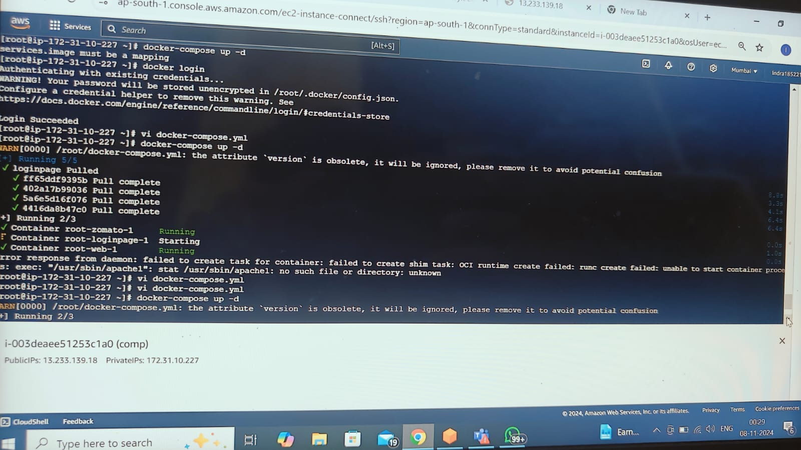

* WE CAN CHECK BY USING IP ADDRESS